**Final Project**

**Date due**

**Project name:** C4IApp

**Absolute URL** (to home page): https://c4iapp.herokuapp.com/public

**Log-in details:** admin/admin to login as administrator. In resident page add new resident with proper email, then click red “verify” button. In email, click the link and copy the given password, account is email address.

|  |
| --- |
| **Instructions on how to hand in assignments** |
| **MANDATORY RULES**   1. Hand in project through Blackboard **on time**. 2. Only the Team Leader is to submit the project web site through Blackboard. 3. If assignment is handed in late, then late penalties will apply. |
| **Assignment Documentation**   1. Upload to blackboard all the files, cover pages, and browser documentation 2. This documentation (including the peer evaluations) is to be submitted to the instructor 3. By submitting this documentation, you agree that all work is your own. 4. Assignments will not be returned back but kept for reference of student progress. (Therefore, keep your own copies of all work handed in) |
| **Late Hand In penalties:**  *Note: ‘Days Late’ are calendar days. This includes weekends, holidays, and all other days.  Subtract 15 % off of mark received - 1 day (up to 24 hours exactly) after due date.  Subtract 30 % off of mark received - 2 days (up to 48 hours exactly) after due date.  Subtract 45 % off of mark received - 3 days (up to 72 hours exactly) after due date.  *** A zero grade will be received if assignment is handed in later than 3 days  (Later than 72 hours exactly) after due date. |
| **Due Dates and Penalties will be re-assessed with any of the following conditions:**  1. Students who are ill and have a physician's letter. This letter must indicate that the student was incapacitated for 1 week prior to the due date of the assignment, in other words, the student could not work for 1 week prior to the due date, from the beginning date that the assignment was assigned. It is assumed that assignments are not done just before the project is due but throughout the previous week. The College will call the physician to confirm the doctor's document. Therefore, please provide the physician's contact details with the physician's letter. If the student has missed many projects, and the marks indicate a failure, and the semester is over, then the student will be asked to repeat the course during the following school year due to limitations of semester time periods at the College.  2. Students who have a death in the family, and can confirm this with proper documentation. This death could be that of a family member or a family pet. The student will be granted a reasonable time to take care of family matters after which the assignment will be required. The College will call the appropriate institutions to confirm this documentation. If the student has missed many assignments, and the marks indicate a failure, and the semester is over, then the student will be asked to repeat the course during the following school year due to limitations of semester time periods at the College.  3. If the student has a family member who is seriously ill, and the student needs to spend time with this family member, then we will need appropriate documentation from the doctor tending the family member. The College will call the physician to confirm this document. Therefore, please provide the physician's contact details with the physician's letter. If the student has missed many assignments, and the marks indicate a failure, and the semester is over, then the student will be asked to repeat the course during the following school year due to limitations of semester time periods at the College. |

***Add/remove and complete the following chart for every team member.

|  |  |
| --- | --- |
| **Team Leader - *Required Information** | |
| Name: | **Jui Ouyang** |
| Student Number: | **N01221239** |
| Email: | **Ohyung1287@gmail.com** |
| Signature:  ***Assignment will not be marked without the student's signature.  ***digital signatures. |  |
| Files “Designed” in this project by this team member (including specific image file names, etc.). | Files Developed in this project by this team member. |
| **Layout.blade** | **Layout.blade** |
| **Verify_email.blade** | **Verify_email.blade** |
| **Profile.blade** | **Profile.blade** |
| **Room.blade** | **Room.blade** |
| **Error.blade** | **Error.blade** |
| **Login.blade** | **Login.blade** |
| **Index.blade** | **Index.blade** |
|  | **ResidentController** |
|  | **ConsoleController** |
|  | **LoginController** |
|  | **RoomSeeder** |
|  | **UserSeeder** |
| **Add rows as needed. |  |

|  |  |
| --- | --- |
| **Team Member - *Required Information** | |
| Name: | **Dongxue Hao** |
| Student Number: | **N01198774** |
| Email: | **dorothy.dongxue.hao@gmail.com** |
| Signature:  ***Assignment will not be marked without the student's signature.  ***No digital signatures. |  |
| Files “Designed” in this project by this team member (including specific image file names, etc.). | Files Developed in this project by this team member. |
| **controller** | **VisitorController.php** |
| **SendEmailController.php** |
| **ParkingController.php** |
| **Mail** | **sendMail.php** |
| **Notification** | **visitorNotification.php** |
| **model** | **Visitors.php** |
| **Emails.php** |
| **Parking.php** |
| **view(admin)** | **emailToResident.blade.php** |
| **availableParking.blade.php** |
| **visitor.blade.php** |
| **visitorLogIn.blade.php** |
| **sendEmail.blade.php** |
| **view(resident)** | **Myvisitor.blade.php** |
| **Add rows as needed. | **Userinterface.blade.php(part)** |

|  |  |
| --- | --- |
| **Team Member - *Required Information** | |
| Name: | **Austin Miranda** |
| Student Number: | **N01245636** |
| Email: | **austin.miranda@outlook.com** |
| Signature:  ***Assignment will not be marked without the student's signature.  ***No digital signatures. |  |
| Files “Designed” in this project by this team member (including specific image file names, etc.). | Files Developed in this project by this team member. |
| **lostfoundtopicsadmin.blade.php** | **LostFoundControler.php** |
| **lostfoundrepliesadmin.blade.php** | **MessageController.php** |
| **package.blade.php** | **NotificationController.php** |
| **lostfoundtopics.blade.php** | **PackageController.php** |
| **lostfoundreplies.blade.php** | **Mail\ConfirmPackage.php** |
| **message.blade.php** | **Notifications\UserMessage.php** |
| **userinterface.blade.php** |  |
| **confirm_package_mail.blade.php** |  |
| **messagessent.blade.php** |  |
|  |  |
|  |  |
|  |  |
|  |  |
|  |  |
| **Add rows as needed. |  |

|  |  |
| --- | --- |
| **Team Member - *Required Information** | |
| Name: | **Ke Xi** |
| Student Number: | **N01243923** |
| Email: | **valeriexi@outlook.com** |
| Signature:  ***Assignment will not be marked without the student's signature.  ***No digital signatures. |  |
| Files “Designed” in this project by this team member (including specific image file names, etc.). | Files Developed in this project by this team member. |
| **fee.blade.php** | **PaymentController** |
| **facility_booking.blade.php** | **FacilityBookingController** |
| **announcement.blade.php** | **AnnouncementController** |
|  |  |
| **Add rows as needed. |  |

|  |  |
| --- | --- |
| **Team Member - *Required Information** | |
| Name: | **Zhengxu Liu** |
| Student Number: | **N01216690** |
| Email: | **vanshg521@gmail.com** |
| Signature:  ***Assignment will not be marked without the student's signature.  ***No digital signatures. |  |
| Files “Designed” in this project by this team member (including specific image file names, etc.). | Files Developed in this project by this team member. |
| **event.blade.php** | **Event.php** |
| **lendings.blade.php** | **Lendings.php** |
| **repair.blade.php** | **Repairs.php** |
| **repairCreate.blade.php** | **EventController.php** |
| **userEvent.blade.php** | **LendingsController.php** |
|  | **RepairController.php** |
|  | **userEventController.php** |
|  | **userRepairController.php** |
|  |  |
|  |  |
|  |  |
|  |  |
|  |  |
|  |  |
| **Add rows as needed. |  |

***NOTE: This is a group mark.

|  |  |  |  |
| --- | --- | --- | --- |
| **Mark:** | **/12** | **/8** | **/20** |
| **Description:** | **User Interface**   * Professional, clean and marketable **(2)**   + - Easy to read content     - Complimentary colors     - Simple, clean design * Easy to navigate / Usability **(2)** * Easy to understand navigation * Easy to locate anything * Understandable page flow * Consistent layout **(2)**/ Cross-browser compatible **(2)** * Use template for all pages * Relevant content/images (not lorem ipsum) **(2)** * Responsive **(2)**   + Tablet, mobile, desktop | **Database design**   * + Proper naming conventions for tables and columns **(3)** * Consistency (with naming-uppercase lowercase) * Meaningful table and column names * Normalize/optimize table **(3)** * Table relationship (primary/foreign key) **(2)** | **Total (for overall web site)** |

***NOTE: The following items are for individual marks.

|  |  |
| --- | --- |
| **Peer Review** | **/5** |

|  |  |  |  |  |
| --- | --- | --- | --- | --- |
| **Mark:** | **/15** | **/5** | **/5** | **/25** |
| **Description:** | **Tier 1**   * Database-driven **(4)** * OOP **(4)** * It works as designed **(2)** * Usability **(1)** * Commenting code descriptively (all files) **(1)** * Labeling controls / Following proper naming conventions **(1)** * Professionalism and functionality **(2)** | **Tier 2**   * Robustness and efficiency **(2)**   + Clear, efficient coding   + Properly structured and maintainable * Dynamic / Interactive **(3)** | **Tier 3**   * Independent initiative (going beyond what has been covered in the course/program) | **Total of 25 marks per page / feature** |

**Developer’s Name:** Jui Ouyang

|  |  |  |  |  |
| --- | --- | --- | --- | --- |
| **Feature #1** | URL: https://c4iapp.herokuapp.com/public/login  Description: Combine user-login and admin-login together, direct to different console page depending on login account . | | | |
| /15 | /5 | /5 | TOTAL /25 |

|  |  |  |  |  |
| --- | --- | --- | --- | --- |
| **Feature #2** | URL: <https://c4iapp.herokuapp.com/public/resident>  https://c4iapp.herokuapp.com/public/room  Description: *Most be login as admin. Add/Remove/Modify the resident or room. Once a resident is created, admin can send a verify email by clicking “verify” button. After resident click the link on email, a user account & password will be created, then resident is able to login as user. | | | |
| /15 | /5 | /5 | TOTAL /25 |

|  |  |  |  |  |
| --- | --- | --- | --- | --- |
| **Feature #3** | URL: https://c4iapp.herokuapp.com/public/profile/{id}  Description:*Most login as resident. Allows resident change their information, or upload the photo. | | | |
| /15 | /5 | /5 | TOTAL /25 |

**Developer’s Name:** Dongxue Hao

__________________________________________________________________________________________

|  |  |  |  |  |
| --- | --- | --- | --- | --- |
| **Feature #1**  visitor | URL:--------------------------------  1) Admin side: visitor logIn with their information and roomNumber he want to visit, and waiting for the resident confirm:At the same time, notification was sent to the resident who he want to visit(by room id)  2) Resident received the notification that this visitor wants to visit you, yes or no?  3) When the resident allowed(which means he clicked yes), visitor’s information are saved in the database, he can go to his visitorList to check this visitor’s information. At the same time, in the admin side, can check the visitors information and with the status “active”  4) When visitor left, he can click the logout button, then this visitor was removed from this resident’s visitor;at the same time, the admin side can see the status of visitor, and if he loggedOut, then can check the “last_time” of this visit.  5) Also admin can search visitors by name/email/phone when click “search” button.          Description: | | | |
| /15 | /5 | /5 | TOTAL /25 |

|  |  |  |  |  |
| --- | --- | --- | --- | --- |
| **Feature #2**  Send Email to resident | URL:--------------------------------  Admin can send email to multiple residents at the same time form admin email account.    Description: | | | |
| /15 | /5 | /5 | TOTAL /25 |

|  |  |  |  |  |
| --- | --- | --- | --- | --- |
| **Feature #3**  **Parking** | URL:--------------------------------  There are still have a lot of things to be done in this feature, including pay parking fee, realtime check…  This is just static data, since the add/update function is similar as visitor and time is not enough, I will do this during this winter break.    Description: | | | |
| /15 | /5 | /5 | TOTAL /25 |

**Developer’s Name:** Ke Xi __________________________________________________________________________________________

|  |  |  |  |  |
| --- | --- | --- | --- | --- |
| **Feature #1** | URL:http://c4iapp.herokuapp.com/public/announcement  Description:*login as admin*  Admin will be able to add/delete/update announcement description, time and date  The announcements will show on every users’ front page when they login | | | |
| /15 | /5 | /5 | TOTAL /25 |

|  |  |  |  |  |
| --- | --- | --- | --- | --- |
| **Feature #2** | URL:http://c4iapp.herokuapp.com/public/facility_booking  Description: *must login as user*  User will be able to request a facility booking if there is no booking at the same time slot. Time out will be calculated automatically based on maximum duration for the facility. They cannot book anytime before current date.  They can also delete their booking.  The booking fee will be shown on users’ invoice page. | | | |
| /15 | /5 | /5 | TOTAL /25 |

|  |  |  |  |  |
| --- | --- | --- | --- | --- |
| **Feature #3** | URL:http://c4iapp.herokuapp.com/public/payment  Description: User will be able to pay for their remaining fee (booking fee etc)  Booking fee added in feature#2 will shown on this page: | | | |
| /15 | /5 | /5 | TOTAL /25 |

**Developer’s Name:** Zhengxu Liu __________________________________________________________________________________________

|  |  |  |  |  |
| --- | --- | --- | --- | --- |
| **Feature #1** | URL:http://c4iapp.herokuapp.com/public/event  Description: *must login as admin*    Admin will be able add or modify events for residents, which will be showing in user page | | | |
| /15 | /5 | /5 | TOTAL /25 |

|  |  |  |  |  |
| --- | --- | --- | --- | --- |
| **Feature #2** | URL:http://c4iapp.herokuapp.com/public/repair  Description:*must login as admin*  Admin will be able to check all repair requests which were submitted by residents from user page. And modify them when they took the requests or finished them | | | |
| /15 | /5 | /5 | TOTAL /25 |

|  |  |  |  |  |
| --- | --- | --- | --- | --- |
| **Feature #3** | URL:http://c4iapp.herokuapp.com/public/lendings  Description:*must login as admin*  Admin will be able to add lending information for residents which will be showing in user page, And modify the data when residents return the lending items. | | | |
| /15 | /5 | /5 | TOTAL /25 |

|  |  |  |  |  |
| --- | --- | --- | --- | --- |
| **Feature #4** | URL:http://c4iapp.herokuapp.com/public/userRepair  Description:*must login as user*  User will be able to add their repair request in this page and send to condo administer, they can also check all repair request information and repair request date, so they can set their date with not conflict with others | | | |
| /15 | /5 | /5 | TOTAL /25 |

|  |  |  |  |  |
| --- | --- | --- | --- | --- |
| **Feature #5** | URL:http://c4iapp.herokuapp.com/public/userEvent  Description:*must login as user*  User will be able to check all event information uploaded by condo admin. | | | |
| /15 | /5 | /5 | TOTAL /25 |

**Developer’s Name:** Austin Miranda

|  |  |  |  |  |
| --- | --- | --- | --- | --- |
| **Feature #1**  **Package Manager** | URL: <http://c4iapp.herokuapp.com/public/package> (need to be logged in as admin)  Description:  Feature will be used when packages are delivered and the receiving Resident is not home.  Admin will add Package into the system with the required information. Package will be placed in the 1 of 10 Community mailbox according to information provided. Resident will be sent Email with Mailbox number and password to pick up their package. Resident can confirm received through email link. Following that Admin can Delete the post. | | | |
| /15 | /5 | /5 | TOTAL /25 |

|  |  |  |  |  |
| --- | --- | --- | --- | --- |
| **Feature #2**  **Lost and Found Board** | URL:<http://c4iapp.herokuapp.com/public/LostFoundTopics>  Description:  Lost and Found Message Board for Residents to post a If they have lost of found something, in the condo. Other Residents can reply to the main posts. All posts and replies can be edited or deleted by the user who made them. Users can use a Search to lookup anything of interest. Feature includes Pagination.  <http://c4iapp.herokuapp.com/public/LostFoundTopicsAdmin> (logged in as Admin)  Admin side has a table of each post, which they can delete if topic is very outdated, unrelated, etc. | | | |
| /15 | /5 | /5 | TOTAL /25 |

|  |  |  |  |  |
| --- | --- | --- | --- | --- |
| **Feature #3**  **Resident-Resident**  **Message** | URL:<http://c4iapp.herokuapp.com/public/message>  Description:  Resident Feature, in which Resident can send a message to another Resident in the system. Residents can view all the messages sent and received. The receiving resident will get a notification in the User Dashboard, indication that s/he has received a message and from whom. Feature includes Pagination. | | | |
| /15 | /5 | /5 | TOTAL /25 |

**Peer Evaluation Form**

Yourself: Jui Ouyang

**Performance Criteria** Excellent Good Average Poor Unacceptable

Attendance 5 4 3 2 1

Contribution 5 4 3 2 1

Task Completion 5 4 3 2 1

Attitude 5 4 3 2 1

Quality of work 5 4 3 2 1

Total Score 22/25

Comments: Build the main logic of system, but not focus on detail things, like validation or user interface.

Team Member #1: **Dongxue Hao**

**Performance Criteria** Excellent Good Average Poor Unacceptable

Attendance 5 4 3 2 1

Contribution 5 4 3 2 1

Task Completion 5 4 3 2 1

Attitude 5 4 3 2 1

Quality of work 5 4 3 2 1

Total Score 20/25

Comments: Hard working, always has a bunch question.

Team Member #2: **Austin Miranda**

**Performance Criteria** Excellent Good Average Poor Unacceptable

Attendance 5 4 3 2 1

Contribution 5 4 3 2 1

Task Completion 5 4 3 2 1

Attitude 5 4 3 2 1

Quality of work 5 4 3 2 1

Total Score 22 /25

Comments: Good self-learning, also gives some good advices on how to improve the project.

Team Member #3: Zhengxu Liu _________________________________________________________________________________

**Performance Criteria** Excellent Good Average Poor Unacceptable

Attendance 5 4 3 2 1

Contribution 5 4 3 2 1

Task Completion 5 4 3 2 1

Attitude 5 4 3 2 1

Quality of work 5 4 3 2 1

Total Score 16/25

Comments: Able to complete his own task, but not familiar with git branch. Need more interact with group.

Team Member #4: Ke Xi _________________________________________________________________________________

**Performance Criteria** Excellent Good Average Poor Unacceptable

Attendance 5 4 3 2 1

Contribution 5 4 3 2 1

Task Completion 5 4 3 2 1

Attitude 5 4 3 2 1

Quality of work 5 4 3 2 1

Total Score 16 /25

Comments: Able to finish her own task, need more interact in group.

Project Screen shot:

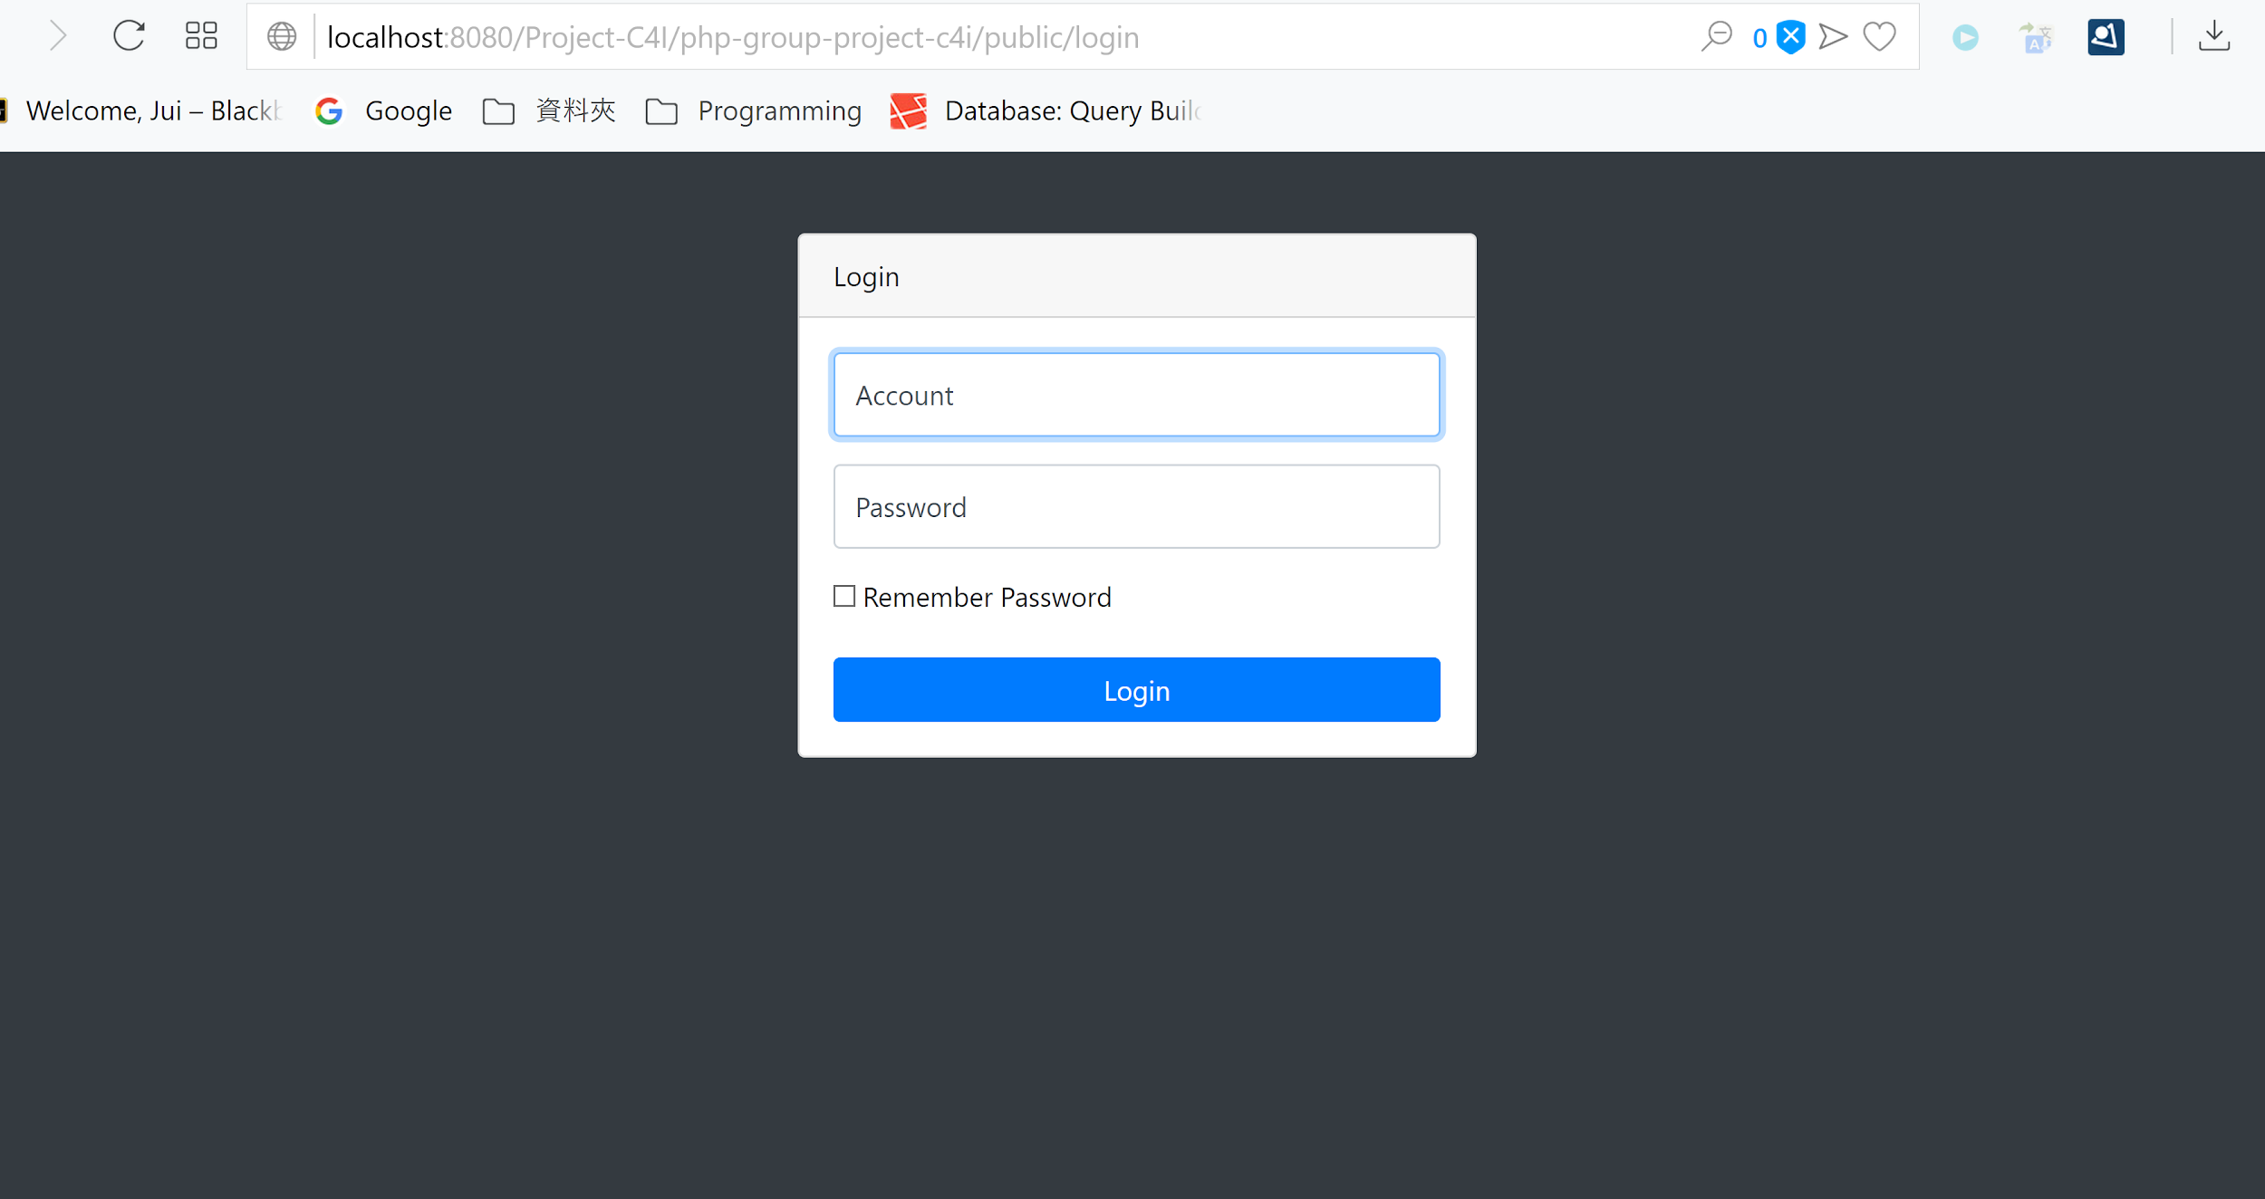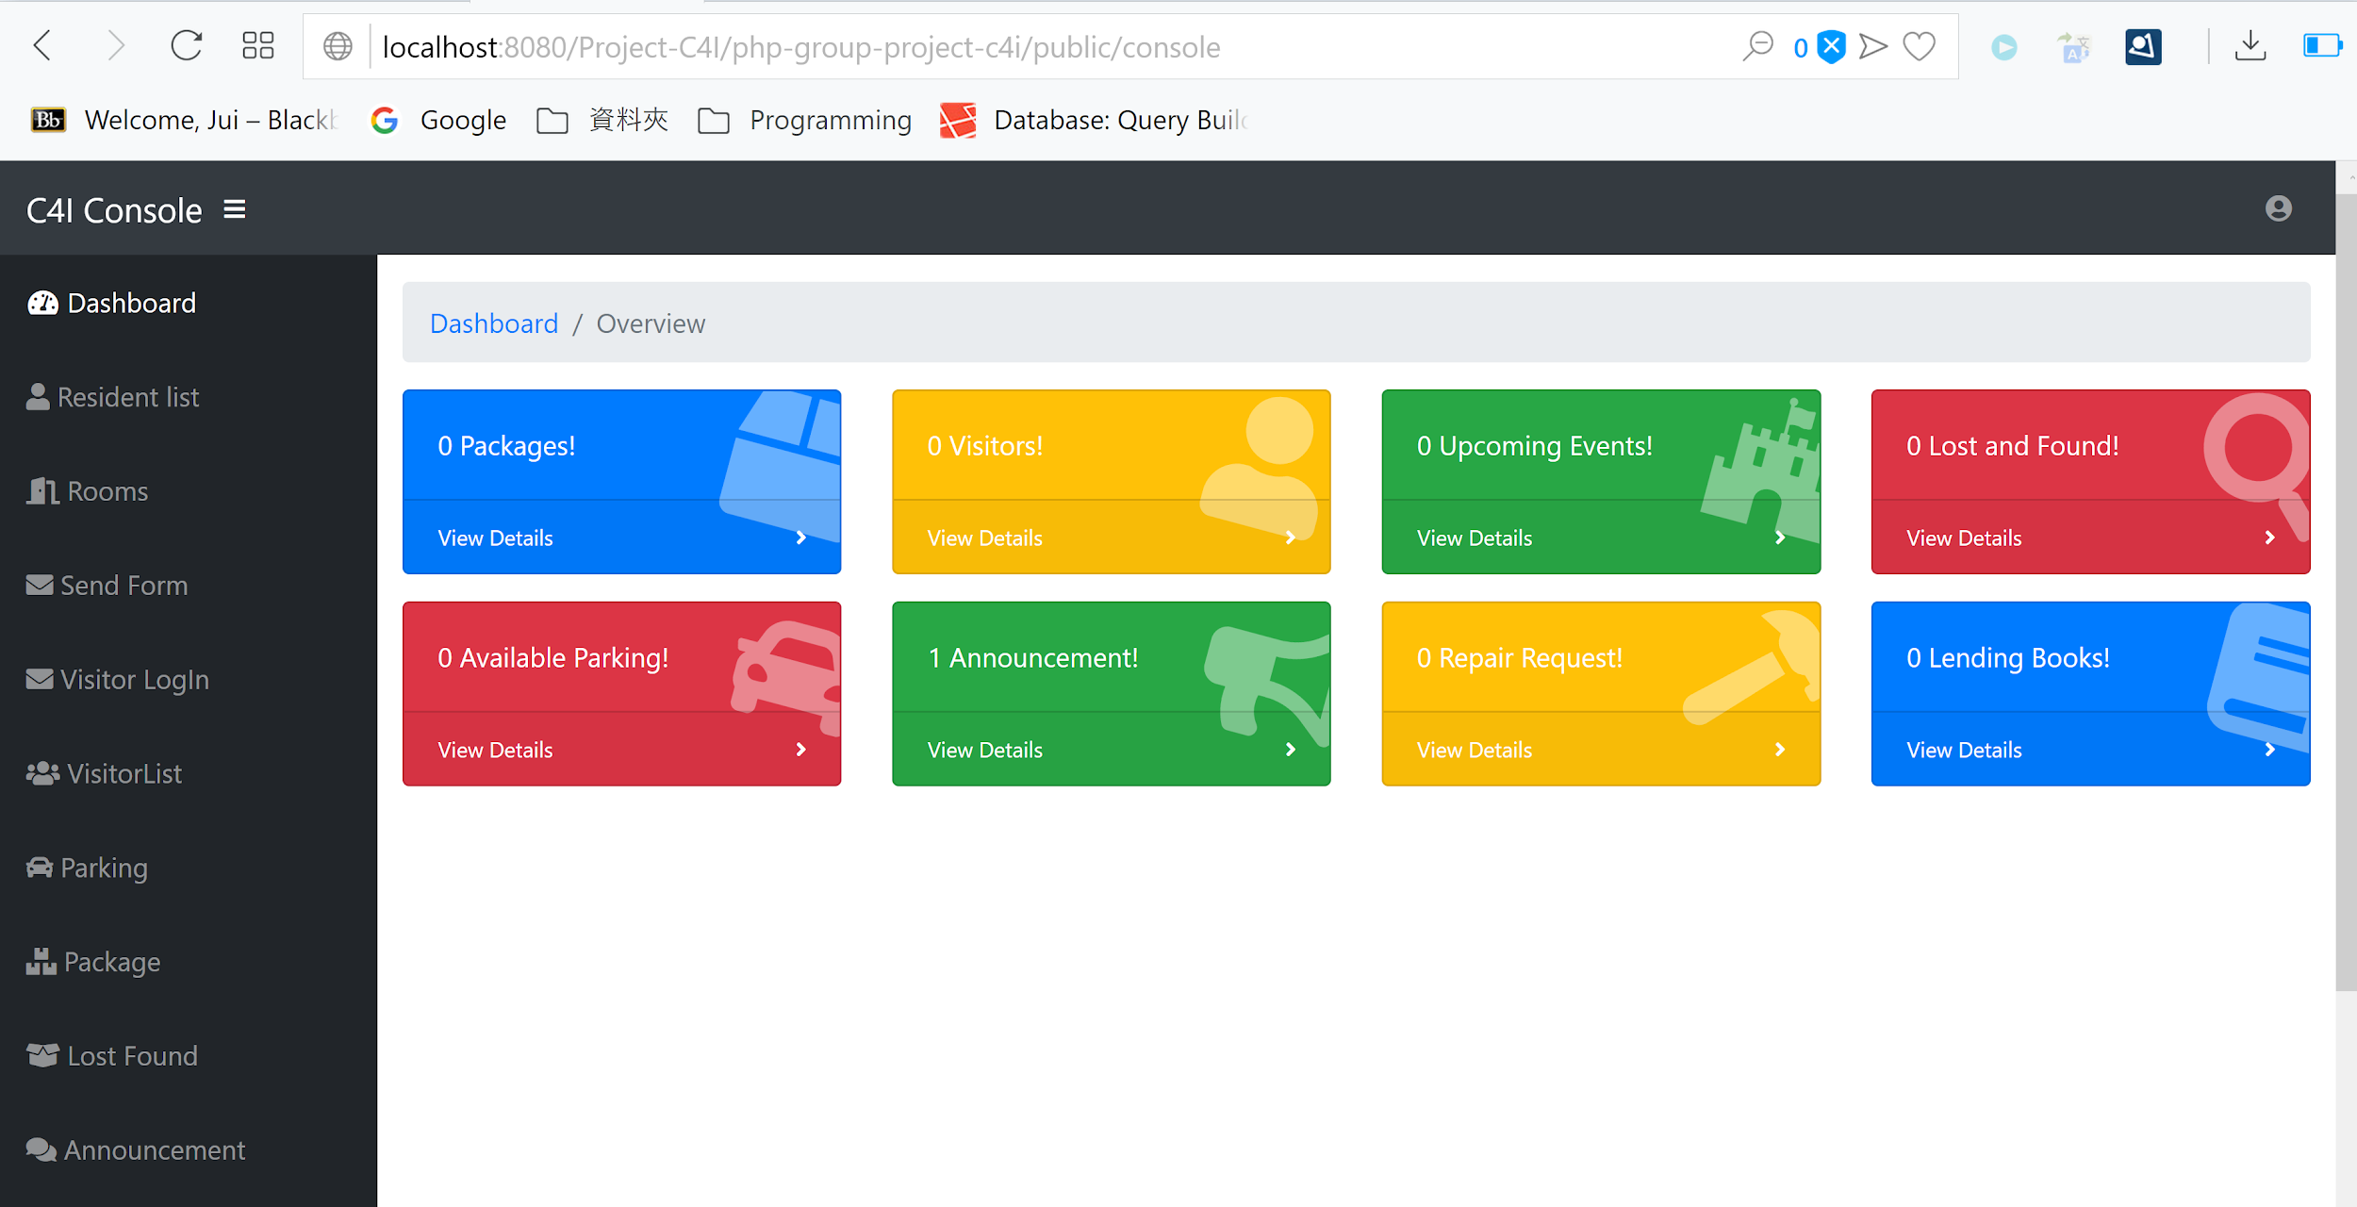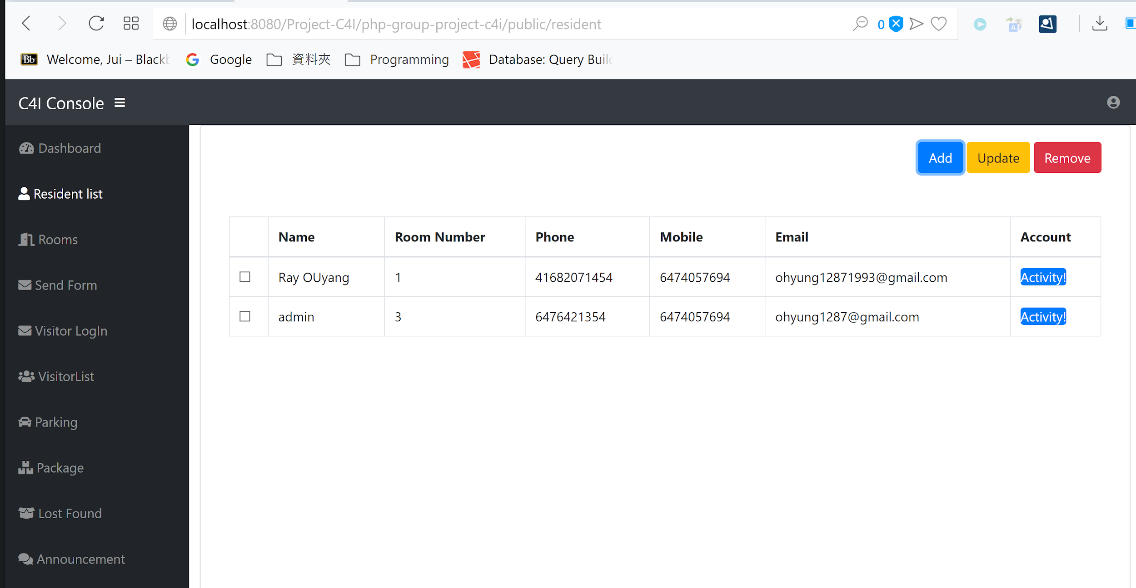

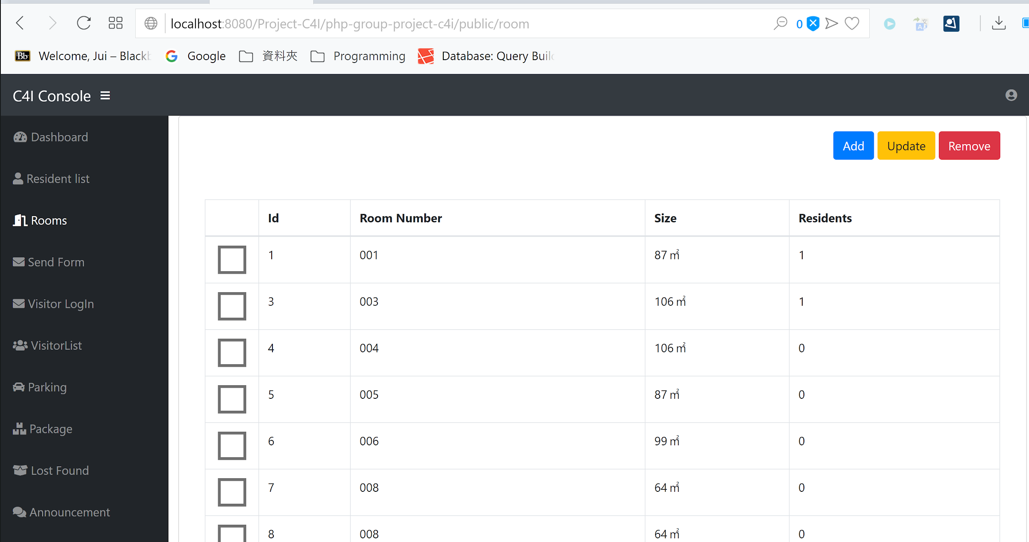

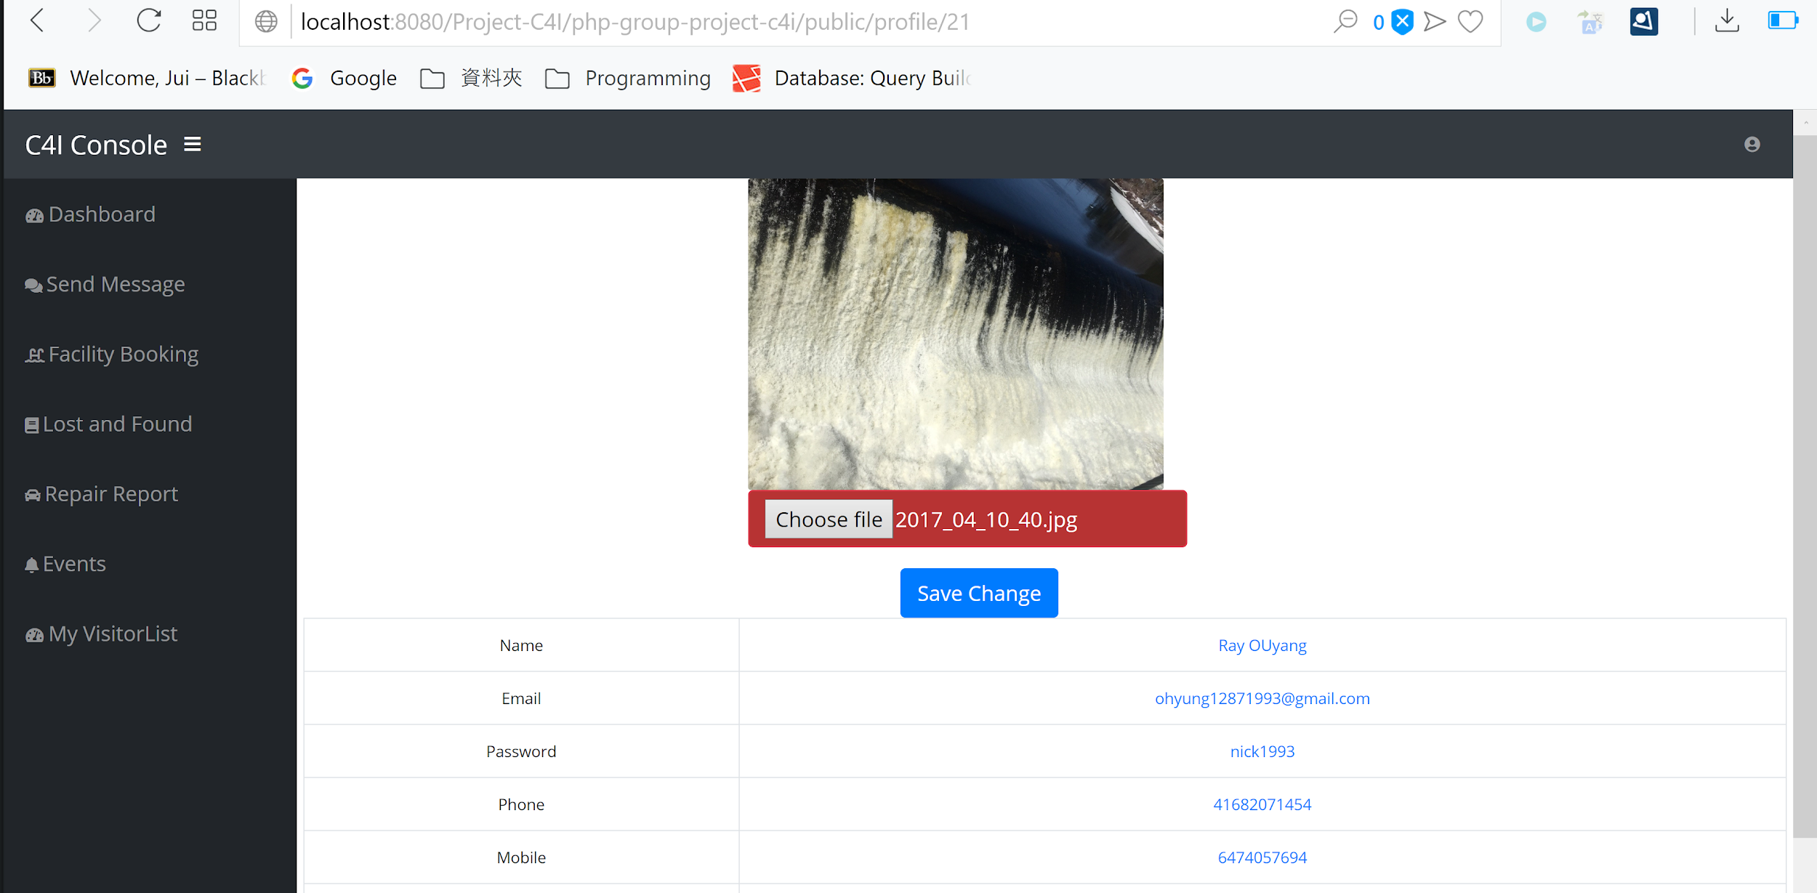

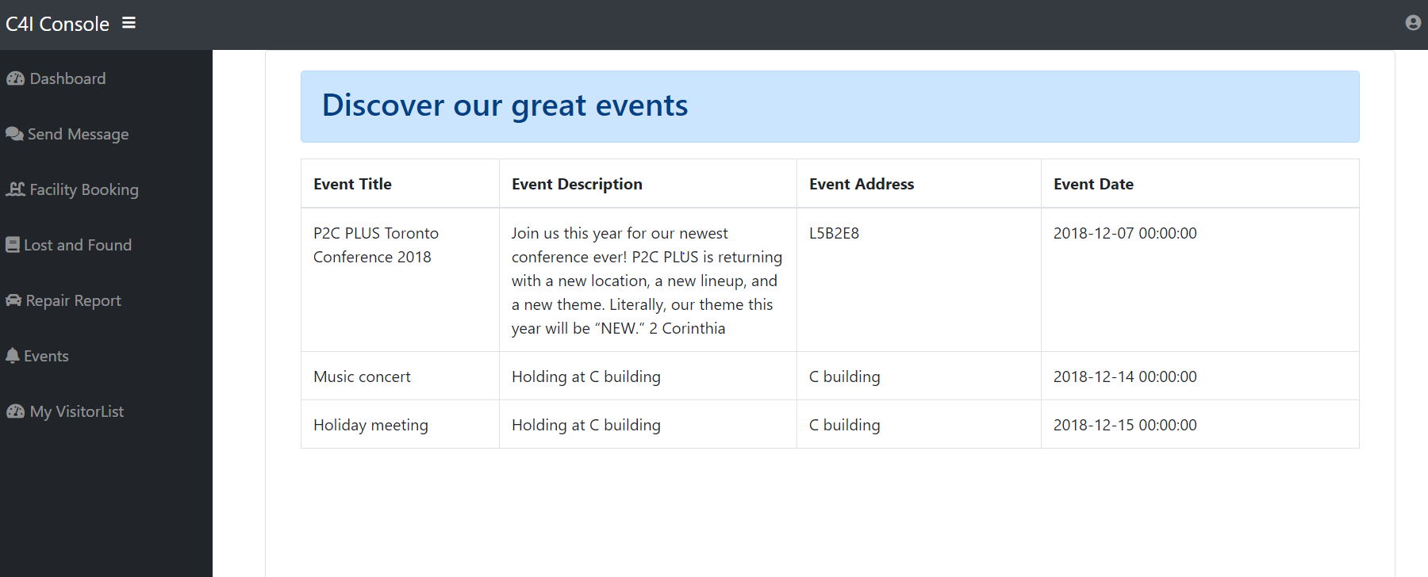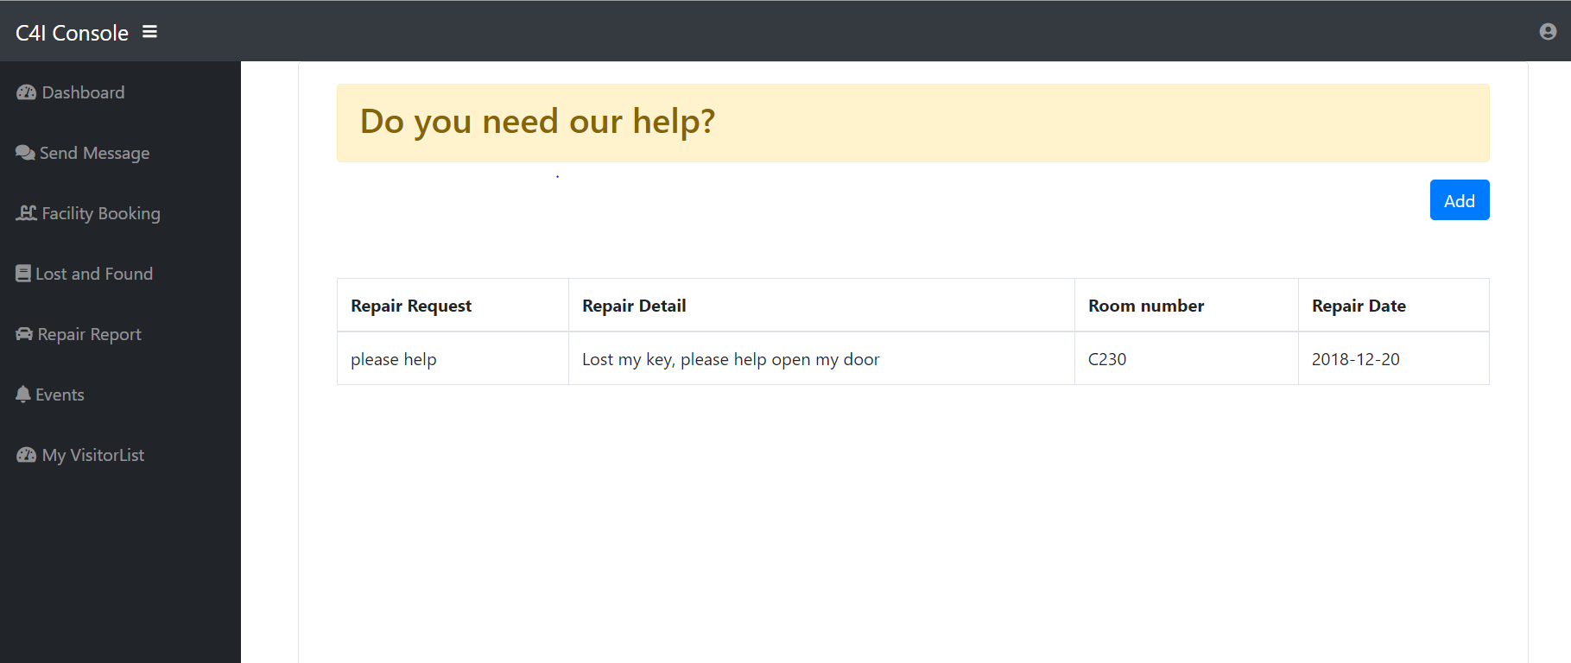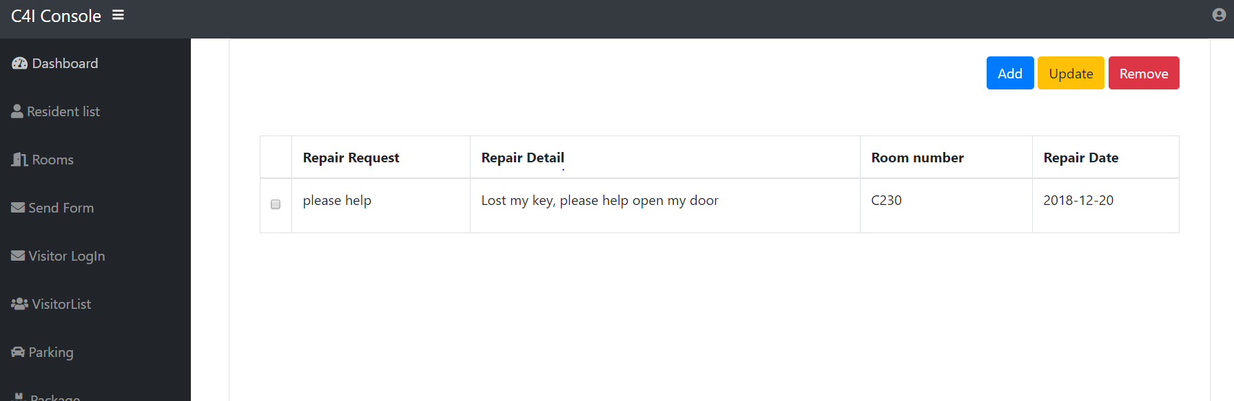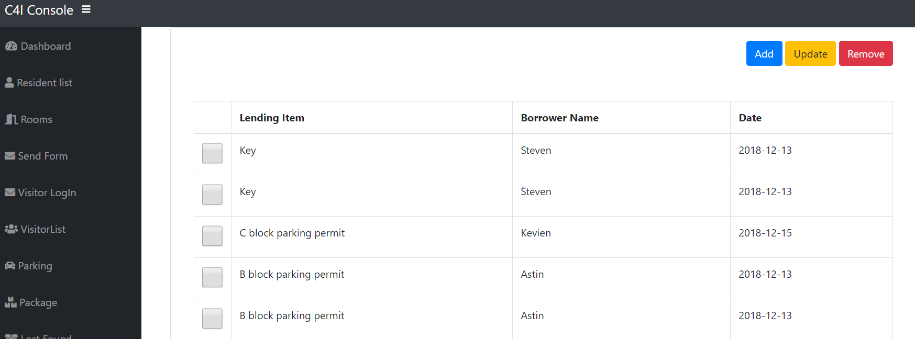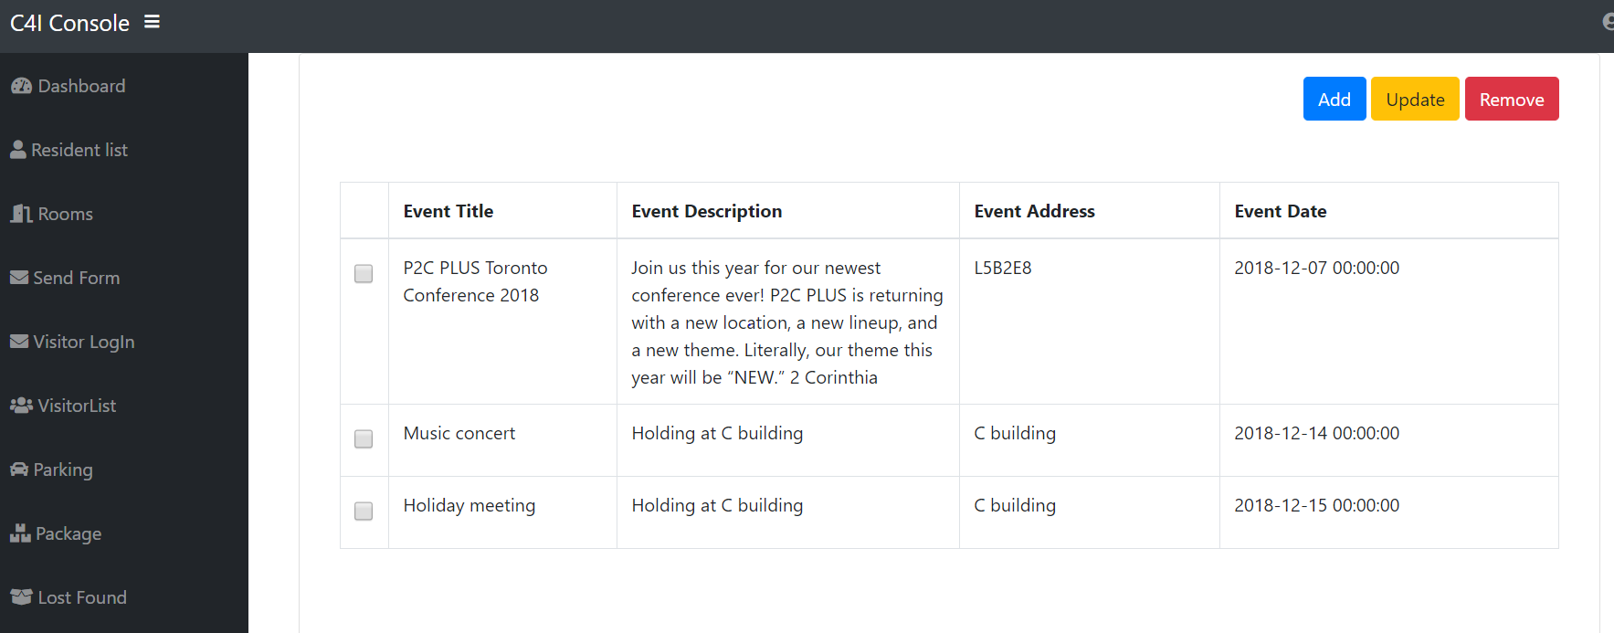

**Package Manager (Admin)**

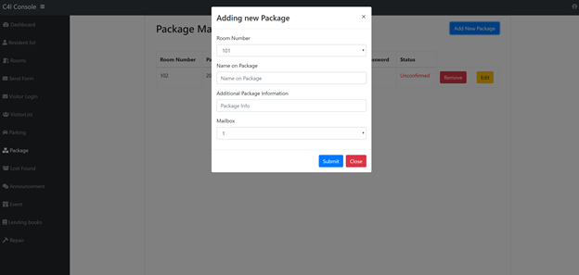

**Lost and Found Board (Resident)**

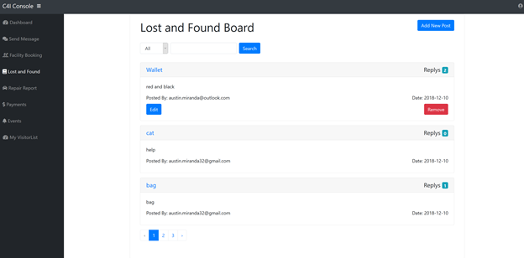

Add new post

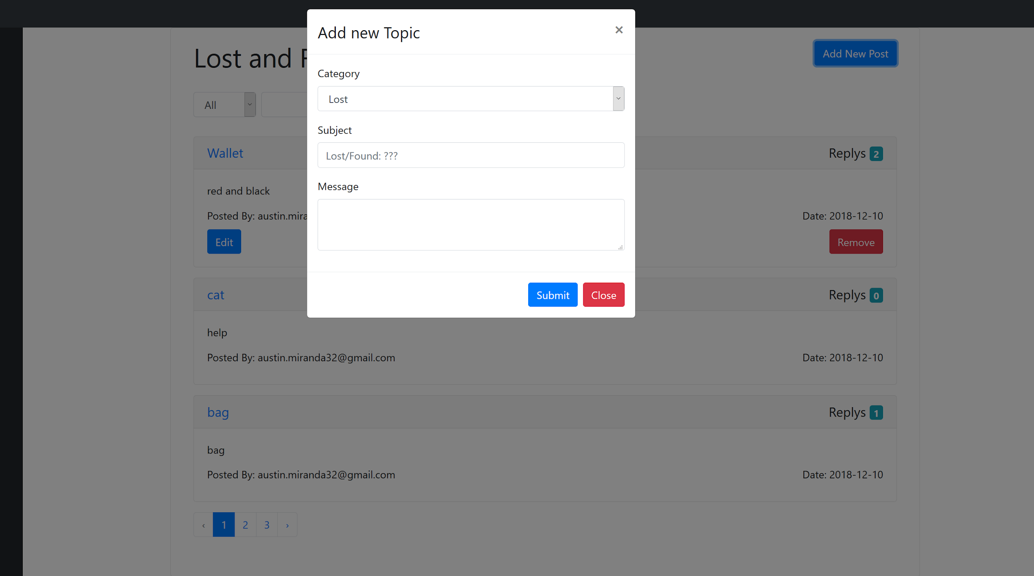

Lost and Found Board Topic Replies (Resident)

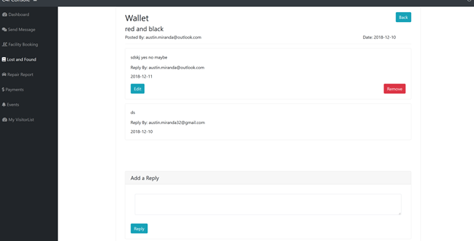

**Lost and Found Board (Admin)**

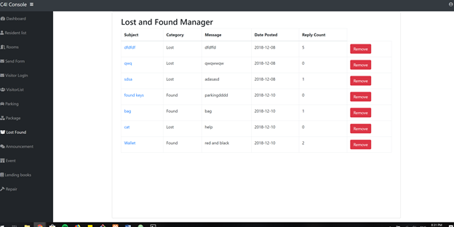

**Resident-Resident Messaging**

Message Notifications

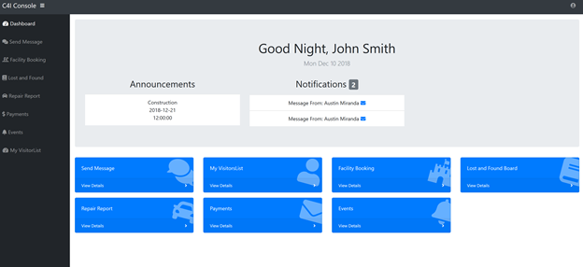

(unviewed messages are highlighted, click to view)

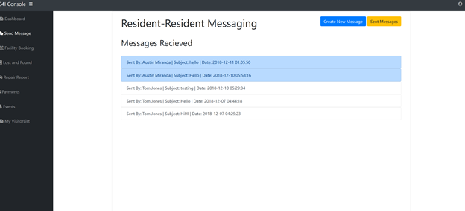

Create Message

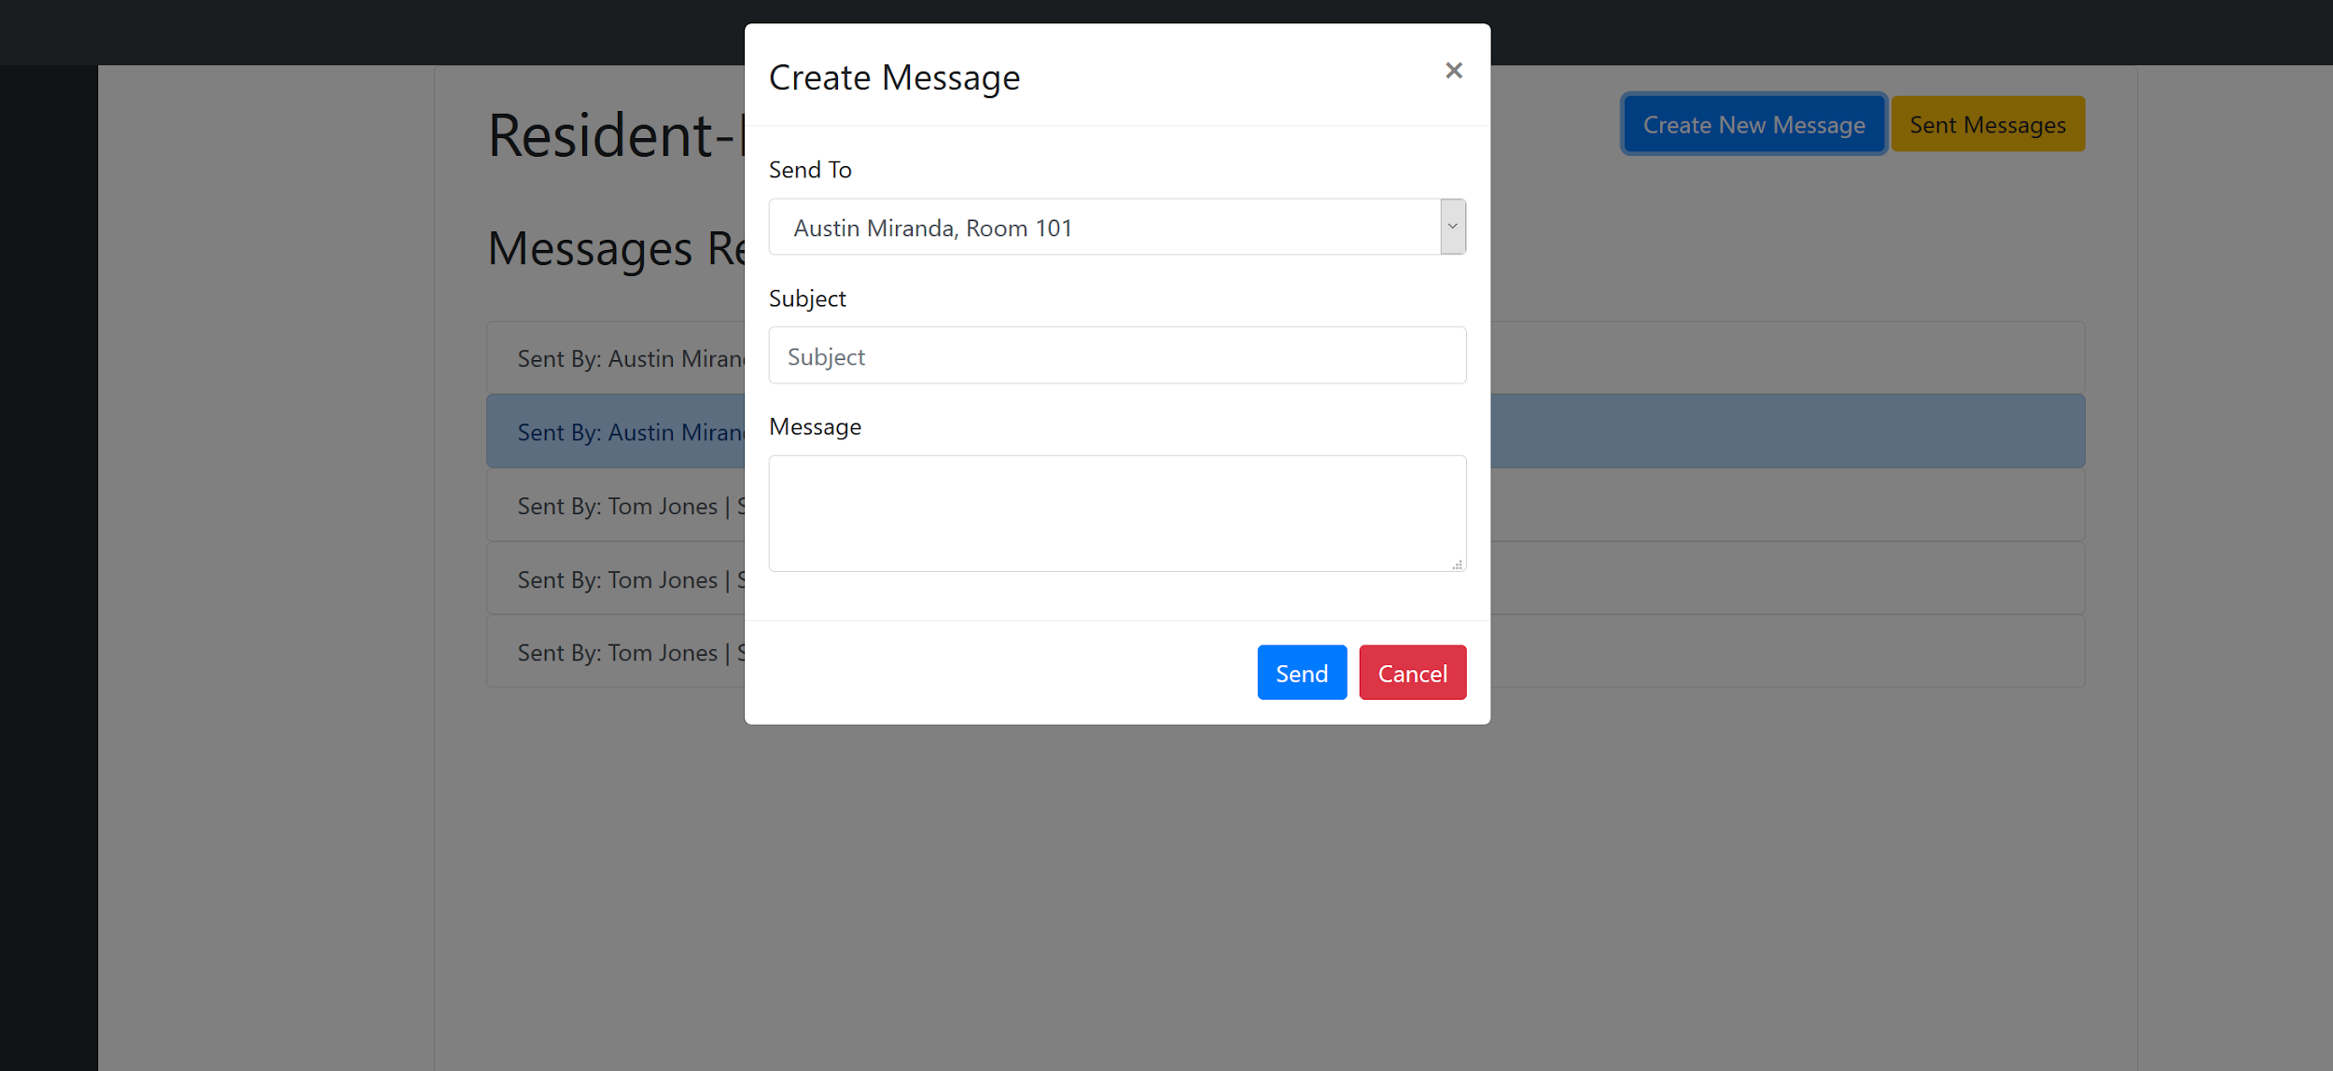

Messages sent

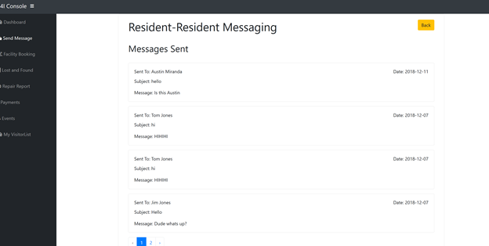

THE FOLLOWING are all REQUIRED TO MARK THIS PROJECT:

USE Microsoft Word for Screen Prints Only, but not design software.

Label each screen print in the Word document.

|  |  |  |  |  |
| --- | --- | --- | --- | --- |
| **Mark with the √ each requirement fulfilled.** | | | | |
| Item | Use the Folder  Name | Include the Following | Format | **√** |
| 1 | your choice | All Code for this assignment | soft copy |  |
| 2 | DB | Database backup for each table as .sql or .txt file | soft copy |  |
| 3 | Images | Images | soft copy |  |
| 4 | CSS | CSS file(s) | soft copy |  |
| 5 | readme.txt | username, password, link to the first page | soft copy |  |
| 6 | Browser | Browser view screen prints of each and every page in assignment. The screen prints must be in a Word file, labeled, and readable at 100% zoom. The URL of the page must be included in the screen print and fully readable. | soft copy |  |
| 7 | DOC | This Assignment Document - filled | soft copy |  |